|  |  |
| --- | --- |
| **EXP.NO: 2** | **Write JavaScript Programme to validate the following fields of the HTML Registration page.** |
| **DATE: 06/02/2025** |

**AIM:**

To write JavaScript code to validate user input in a registration form. The validation will ensure that the data entered by the user meets specific criteria for each field. This will help in maintaining data integrity and prevent invalid submissions.

**ALGORITHM:**

1. **Input:**
   * The user fills in the following fields: **First Name**, **Password**, **E-mail**, **Mobile Number**, **Last Name**, and **Address**.
2. **Validation Steps:**
3. **Validate First Name:**
   * Check if the first name contains **only alphabets**.
   * Ensure the length of the **First Name** is **at least 6 characters**.
   * If any of these conditions fail, display an error message indicating the required input.
4. **Validate Password:**
   * Check if the password is **at least 6 characters long**.
   * If it is less than 6 characters, display an error message.
5. **Validate E-mail:**
   * Use a **regular expression** to check if the email follows the standard pattern: [name@domain.com.](mailto:name@domain.com)
   * Ensure that the email contains **no invalid characters** and matches the required pattern.
   * If it doesn't match, display an error message indicating an invalid email format.
6. **Validate Mobile Number:**
   * Check if the mobile number contains **exactly 10 digits**.
   * Ensure there are **no alphabets or special characters**.
   * If the number is invalid, display an error message indicating the correct format.
7. **Validate Last Name:**
   * Ensure the **Last Name** field is **not empty**.
   * If it is empty, display an error message.
8. **Validate Address:**
   * Ensure the **Address** field is **not empty**.
   * If it is empty, display an error message.

**CODE:**

**Index.html:**

<!DOCTYPE html>

<html>

<head>

<title>Online Restaurant Booking</title>

</head>

<frameset rows="100,60,*">

<frame src="header.html" name="headerFrame" noresize>

<frame src="menu.html" name="menuFrame" noresize scrolling="no">

<frame src="home.html" name="contentFrame">

</frameset>

</html>

**Menu.html :**

<!DOCTYPE html>

<html>

<head>

<style>

body{

margin:0;

font-family:Arial;

background:transparent;

}

.menu{

display:flex;

justify-content:center;

background:rgba(0,0,0,0.8);

}

.menu a{

color:white;

padding:15px 30px;

text-decoration:none;

font-weight:bold;

letter-spacing:1px;

}

.menu a:hover{

background:rgba(255,255,255,0.2);

}

</style>

</head>

<body>

<div class="menu">

<a href="home.html" target="contentFrame">HOME</a>

<a href="foodmenu.html" target="contentFrame">MENU</a>

<a href="booking.html" target="contentFrame">BOOK TABLE</a>

<a href="contact.html" target="contentFrame">LOCATION</a>

</div>

</body>

</html>

**Header.html :**

<!DOCTYPE html>

<html>

<head>

<style>

body{

margin:0;

background-color:black;

color:white;

text-align:center;

font-family:Arial, sans-serif;

}

.logo{

display:flex;

justify-content:center;

align-items:center;

padding:15px;

}

.logo img{

width:50px;

margin-right:15px;

}

h1{

letter-spacing:3px;

}

</style>

</head>

<body>

<div class="logo">

<img src="logo.jpg" alt="Dragon Logo">

<h1>DRAGON STONE</h1>

</div>

</body>

</html>

**Home.html :**

<!DOCTYPE html>

<html>

<head>

<style>

body{

margin:0;

font-family:Arial, sans-serif;

background-image:url("image.jpg");

background-size:cover;

background-position:center;

color:white;

}

.overlay{

background:rgba(0,0,0,0.7);

padding:50px;

min-height:100vh;

}

h2{

font-size:40px;

margin-bottom:10px;

}

p{

font-size:18px;

line-height:1.6;

max-width:800px;

}

</style>

</head>

<body>

<div class="overlay">

<h2>Welcome to Dragon Stone</h2>

<p>

Welcome to Dragon Stone, where every dish is crafted with passion and every visit feels like home. We bring together fresh ingredients, rich flavors, and a warm ambiance to create an unforgettable dining experience. Whether you're here for a quick bite or a special celebration, we are delighted to serve you.

</p>

<br><br>

<h2>About Us</h2>

<p>

Welcome to Dragon Stone, where flavor meets passion and every meal tells a story.

Founded with a love for great food and warm hospitality, our restaurant is more than just a place to dine — it’s a place to connect, celebrate, and create unforgettable memories. We blend fresh ingredients, bold flavors, and modern culinary techniques to craft dishes that satisfy both the heart and the palate.

Our chefs carefully select quality ingredients to ensure every plate served reflects excellence, creativity, and authenticity. Whether you’re joining us for a casual lunch, a family dinner, or a special celebration, we strive to make every visit exceptional.

At Dragon Stone, we believe great food brings people together. From our welcoming ambiance to our attentive service, everything we do is designed to give you an experience worth savoring.

We look forward to serving you.Book your table online and enjoy a seamless dining experience.

</p>

</div>

</body>

</html>

**Foodmenu.html :**

<!DOCTYPE html>

<html>

<head>

<title>Dragon Stone - Specials</title>

<style>

body{

margin:0;

font-family:Arial, sans-serif;

background-color:#111;

color:white;

text-align:center;

}

h2{

padding:20px;

}

.gallery{

display:flex;

flex-wrap:wrap;

justify-content:center;

gap:30px;

padding:20px;

}

.item{

width:300px;

}

.item img{

width:100%;

height:250px;

object-fit:cover;

border-radius:10px;

}

.item h3{

margin-top:10px;

}

</style>

</head>

<body>

<h2> Dragon Stone - Our Food</h2>

<div class="gallery">

<div class="item">

<img src="briyani.jpg">

<h3>Chicken Biryani</h3>

</div>

<div class="item">

<img src="dosa.jpg">

<h3>Dosa</h3>

</div>

<div class="item">

<img src="fried rice.jpg">

<h3>Fried Rice</h3>

</div>

<div class="item">

<img src="grill.jpg">

<h3>Grilled Chicken</h3>

</div>

<div class="item">

<img src="idli.jpg">

<h3>Idli</h3>

</div>

<div class="item">

<img src="kebab.jpg">

<h3>Tandoori Kebab</h3>

</div>

<div class="item">

<img src="meals.jpg">

<h3>South Indian Meals</h3>

</div>

<div class="item">

<img src="paratha.jpg">

<h3>Paratha</h3>

</div>

<div class="item">

<img src="tandoori.jpg">

<h3>Tandoori Chicken</h3>

</div>

</div>

</body>

</html>

**Contact :**

<!DOCTYPE html>

<html>

<head>

<title>Dragon Stone - Contact</title>

<style>

body{

margin:0;

font-family:Arial, sans-serif;

background-image:url("image.jpg");

background-size:cover;

background-position:center;

color:white;

}

.overlay{

background:rgba(0,0,0,0.85);

min-height:100vh;

padding:40px;

}

.container{

display:flex;

justify-content:center;

align-items:center;

gap:40px;

}

.contact-info{

max-width:300px;

line-height:1.8;

}

iframe{

border-radius:10px;

}

h2{

text-align:center;

margin-bottom:30px;

}

</style>

</head>

<body>

<div class="overlay">

<h2>📍 Dragon Stone - Contact Us</h2>

<div class="container">

<!-- Google Map -->

<iframe src="https://www.google.com/maps/embed?pb=!1m18!1m12!1m3!1d15544.583375638294!2d80.19728679531214!3d13.089941945780323!2m3!1f0!2f0!3f0!3m2!1i1024!2i768!4f13.1!3m3!1m2!1s0x3a5264078822719b%3A0xbda01077b89581e2!2sAnna%20Nagar%2C%20Chennai%2C%20Tamil%20Nadu!5e0!3m2!1sen!2sin!4v1771429378999!5m2!1sen!2sin" width="600" height="450" style="border:0;" allowfullscreen="" loading="lazy" referrerpolicy="no-referrer-when-downgrade"></iframe>

<!-- Contact Details -->

<div class="contact-info">

<h3>Contact Details</h3>

📞 <strong>Contact No:</strong><br>

+91 98765 43210 <br><br>

📧 <strong>Email:</strong><br>

dragonstone@gmail.com <br><br>

📍 <strong>Address:</strong><br>

Dragon Stone Restaurant,<br>

Anna Nagar,<br> Chennai,<br>

Tamil Nadu, India.

</div>

</div>

</div>

</body>

</html>

**Booking.html :**

<!DOCTYPE html>

<html>

<head>

<title>Dragon Stone - Table Booking</title>

<style>

body{

margin:0;

font-family:Arial, sans-serif;

background-image:url("image.jpg");

background-size:cover;

background-position:center;

color:white;

}

.overlay{

background:rgba(0,0,0,0.8);

min-height:100vh;

display:flex;

justify-content:center;

align-items:center;

}

.form-container{

background:rgba(0,0,0,0.9);

padding:30px;

border-radius:10px;

width:350px;

text-align:center;

}

input{

width:100%;

padding:8px;

margin-top:5px;

margin-bottom:15px;

border:none;

border-radius:4px;

}

input[type="submit"]{

background-color:#c0392b;

color:white;

font-weight:bold;

cursor:pointer;

}

input[type="submit"]:hover{

background-color:#e74c3c;

}

</style>

<script>

function validateBooking() {

var name = document.forms["bookingForm"]["customerName"].value;

var mobile = document.forms["bookingForm"]["mobile"].value;

var email = document.forms["bookingForm"]["email"].value;

var date = document.forms["bookingForm"]["date"].value;

var time = document.forms["bookingForm"]["time"].value;

var guests = document.forms["bookingForm"]["guests"].value;

var namePattern = /^[A-Za-z\s]+$/;

var mobilePattern = /^[0-9]{10}$/;

var emailPattern = /^[A-Za-z0-9._%+-]+@[A-Za-z0-9.-]+\.[A-Za-z]{2,}$/;

if (!namePattern.test(name) || name.length < 6) {

alert("Name must contain only alphabets and minimum 6 characters.");

return false;

}

if (!mobilePattern.test(mobile)) {

alert("Mobile number must contain exactly 10 digits.");

return false;

}

if (!emailPattern.test(email)) {

alert("Enter a valid email (example: name@domain.com).");

return false;

}

if (date == "") {

alert("Please select booking date.");

return false;

}

if (time == "") {

alert("Please select booking time.");

return false;

}

if (guests == "" || guests <= 0) {

alert("Number of guests must be greater than 0.");

return false;

}

alert("Table Booking Successful at Dragon Stone!");

return true;

}

</script>

</head>

<body>

<div class="overlay">

<div class="form-container">

<h2> Dragon Stone</h2>

<h3>Online Table Booking</h3>

<form name="bookingForm" onsubmit="return validateBooking()">

Customer Name:

<input type="text" name="customerName">

Mobile Number:

<input type="text" name="mobile">

Email:

<input type="text" name="email">

Booking Date:

<input type="date" name="date">

Booking Time:

<input type="time" name="time">

Number of Guests:

<input type="number" name="guests" min="1">

<input type="submit" value="Book Table">

</form>

</div>

</div>

</body>

</html>

**OUTPUT:**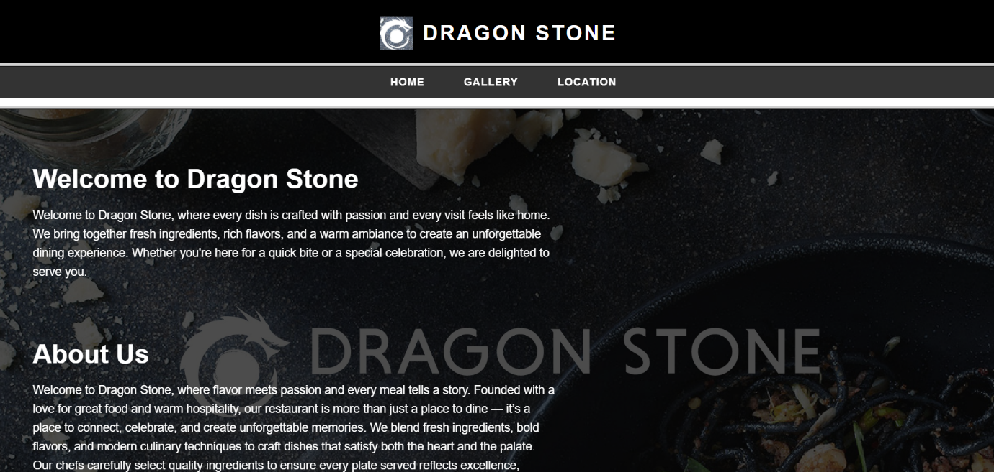

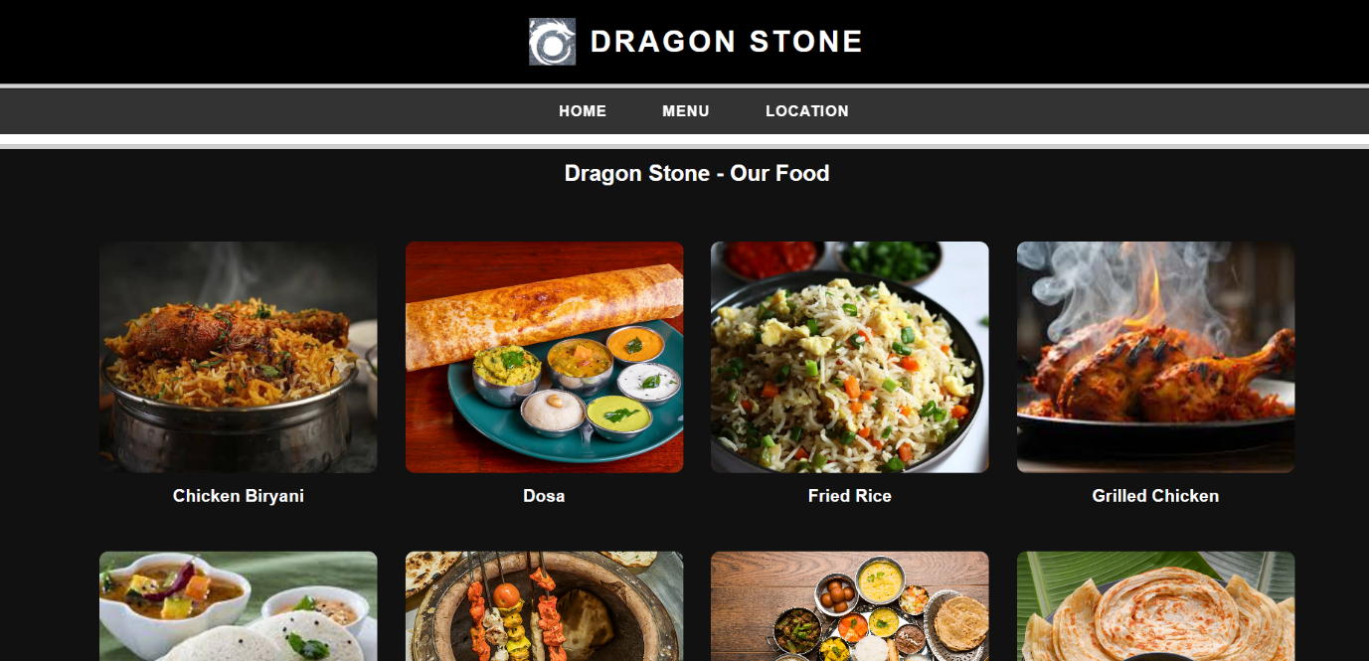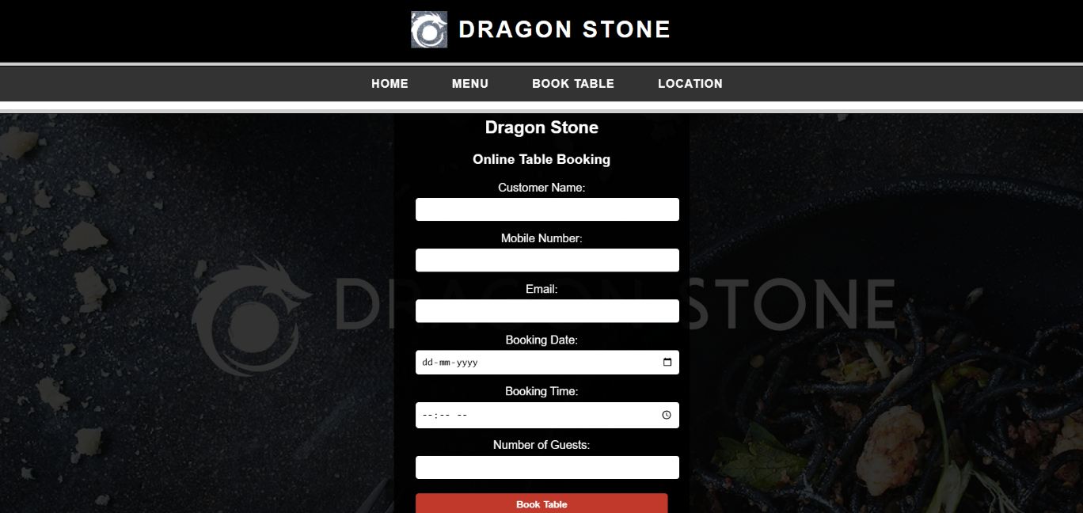

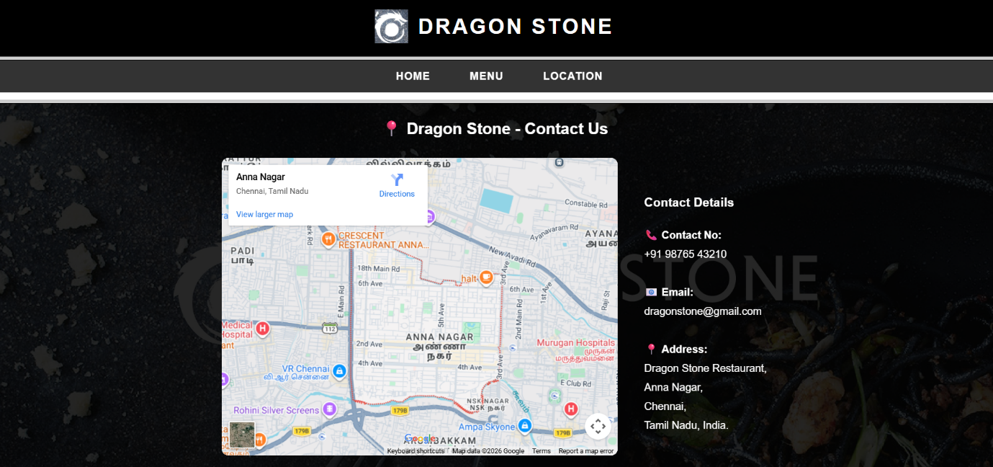

**RESULT:**

HTML page with Form is created and is validated using Javascript